Technical Architecture:

Project Design Phase-II Technology Stack (Architecture & Stack)

Date | 25-06-2025
Team ID | 23A51A0215
Project Name | Metro Ticket Generating System in ServiceNow
Maximum Marks | 4 Marks

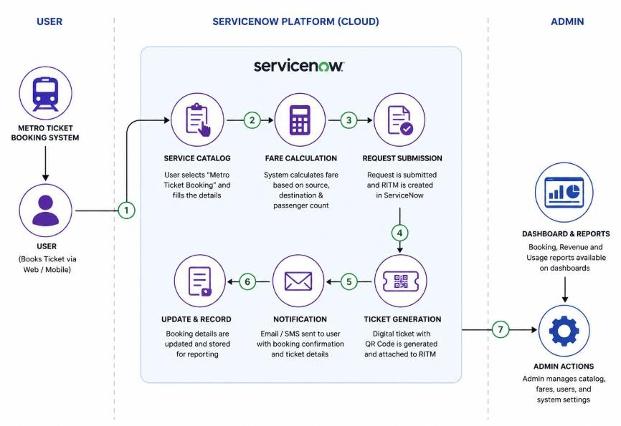

Table-1 : Components & Technologies:

S.No | Component | Description | Technology
1. | User Interface | Interface for passengers to book metro tickets | ServiceNow Service Catalog, Portal UI
2. | Application Logic-1 | Fare calculation based on source and destination stations | Catalog Client Scripts (JavaScript)
3. | Application Logic-2 | Server-side fare retrieval and validation | Script Includes, GlideAjax
4. | Application Logic-3 | Automated ticket booking workflow and notifications | Flow Designer, Business Rules
5. | Database | Stores metro stations, fares, and booking information | ServiceNow Tables (u_metro_station, u_metro_fare, sc_req_item)
6. | Cloud Database | Cloud-based data storage managed by ServiceNow | ServiceNow Cloud Database
7. | File Storage | Stores QR codes, ticket attachments, and records | ServiceNow Attachments
8. | External API-1 | QR Code generation for digital tickets | QR Code Generator API / Scripted QR Generation
9. | External API-2 | Email notification service for ticket confirmation | ServiceNow Notification Engine
10. | Machine Learning Model | Ticket booking trends, revenue, and usage reports | ServiceNow Reports & Dashboards
11. | Infrastructure (Server / Cloud) | Application hosting and execution environment | ServiceNow SaaS Cloud Platform

Table-2: Application Characteristics:

S.No | Characteristics | Description | Technology
1. | Open-Source Frameworks | Client-side scripting and customization used for fare calculation and form validation | JavaScript, GlideAjax
2. | Security Implementations | Role-based access control for administrators and  users, authenticated access through ServiceNow platform, secure data storage and transmission | ServiceNow ACLs, User Roles, HTTPS, IAM Controls
3. | Scalable Architecture | ServiceNow's cloud-based multi-tenant architecture supports growing users and ticket  bookings without infrastructure changes | ServiceNow SaaS Architecture, Multi-Tenant Cloud Platform
4. | Availability | High availability through ServiceNow cloud infrastruc managed services | tServiceNow Cloud Infrastructure, d Ruereduwnitdhacnot nDtaintuaoCuesnmteornsitoring an
5. | Performance | Fast ticket booking process through server-side proc cloud-hosted services | eGlideAjax, Script Includes, ServiceNowd Dsastianbga, soeptOimpitzimedizadtaiotanbase queries, an

References:
https://www.servicenow.com/docs/r/servicenow-platform/service-catalog/service-catalog.html https://www.servicenow.com/docs/r/application-development/building-applications/flow-designer.html https://www.servicenow.com/docs/r/api-reference/c_GlideAjaxAPI.html https://developer.servicenow.com
https://www.servicenow.com/community/

